Chosen Environment
I selected Google Colab because it runs directly in a web browser and connects with my Google account. I checked out Kaggle and Binder, but they seemed more advanced and required extra steps. Colab felt familiar and beginner-friendly.
Setup Experience
Starting a notebook was simple: I signed in with my Google account, clicked New Notebook, and was ready to code. No downloads or installations were needed, which saved a lot of time and confusion.
Program Executed
I created a small Python project called “Daily Temperature Tracker.”
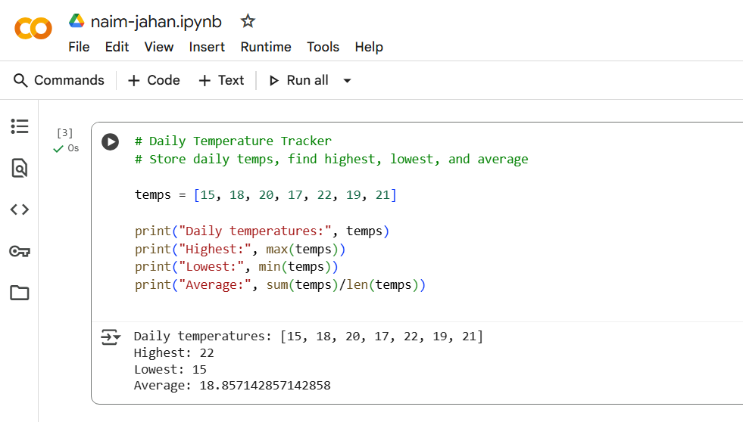
Obstacles and Solutions
My only confusion was about saving the notebook. At first I wasn’t sure if the work stayed online, but after linking it to Google Drive I saw it auto-save, so no more worries.

Convenience and Recommendation
Colab is very convenient for beginners: nothing to install, runs in any browser, and saves automatically to Drive. I would definitely recommend it to classmates who are new to Python or don’t want to set up a local environment.

